Docker Task -02

Task Title
Containerization and Image Management using Docker, Docker Hub, and AWS ECR
Objective
The objective of this task is to gain hands-on experience with Docker by deploying containers, managing container resources, creating custom Docker images, using Docker volumes, and publishing images to public and private container registries. This includes deploying Tomcat and Nginx containers, limiting container resources, creating a custom Dockerfile using Amazon Linux, and pushing Docker images to Docker Hub and AWS Elastic Container Registry (ECR).
Prerequisites
- Linux server (Ubuntu) with root or sudo access
- Docker installed and running
- Internet connectivity to pull images
- Docker Hub account
- AWS account with IAM credentials
- AWS CLI installed and configured
- Basic knowledge of Docker commands
- Basic understanding of containers and images
Conclusion
In this task, Docker was successfully used to deploy and manage containerized applications. A Tomcat container was created on port 8080 and a sample application was deployed. Docker volumes were utilized to deploy another Tomcat container on port 8081, ensuring persistent storage. An Nginx container was launched with a memory limit of 500 MB to demonstrate resource management. A custom Docker image was built using Amazon Linux as the base image, with Nginx installed and a custom HTML file deployed. The custom image was successfully pushed to Docker Hub for public access and to AWS Elastic Container Registry (ECR) for private cloud-based image storage. This task demonstrates end-to-end container lifecycle management, from image creation to deployment and registry integration.

- Create a tomcat container on 8080 and deploy sample application in tomcat.
Steps performed:
- Pulled the Tomcat image from Docker Hub
Command: docker pull tomcat
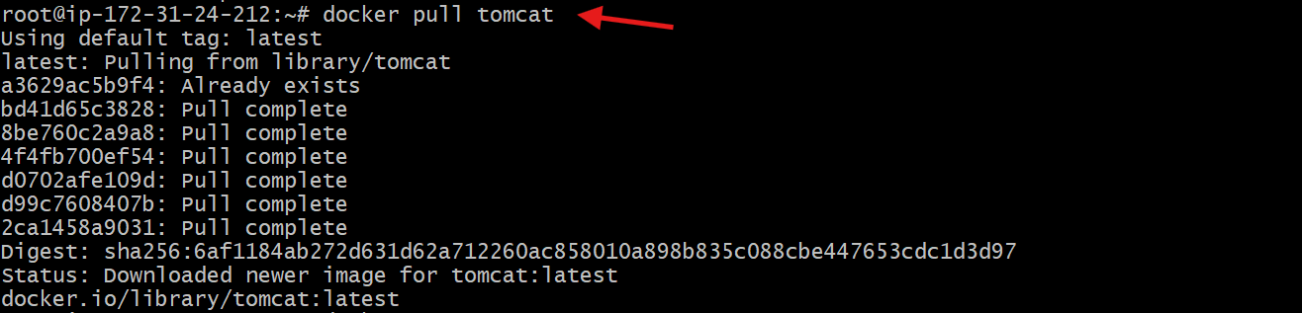
2.Ran the Tomcat container in detached mode and mapped port 8080
Command: docker container run -itd -p 8080:8080 tomcat
3.Entered the running Tomcat container
Command: docker exec -it <container_id> /bin/bash
4.Moved to the Tomcat webapps directory
Use: cd /usr/local/tomcat/webapps
5. Downloaded the sample application WAR file
Command: wget https://tomcat.apache.org/tomcat-5.5-doc/appdev/sample/sample.war
6.Verified that the WAR file was downloaded and auto-deployed
Ls & ll
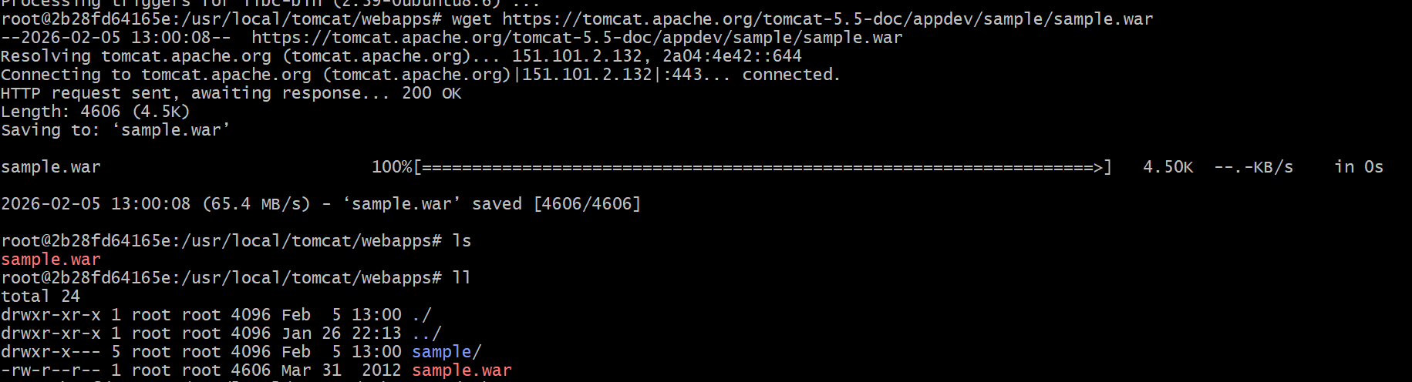
7.Accessed the sample application in the browser
Use: http://<server-ip>:8080/sample
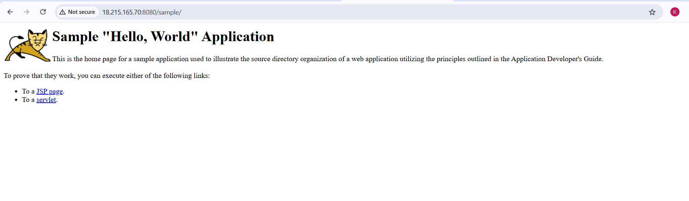
- Create volume and deploy tomcat container on port 8081.
Steps performed:
- Created a Docker volume named deployment
Command: docker volume create deployment
- Listed Docker volumes to verify creation
Command: docker volume ls
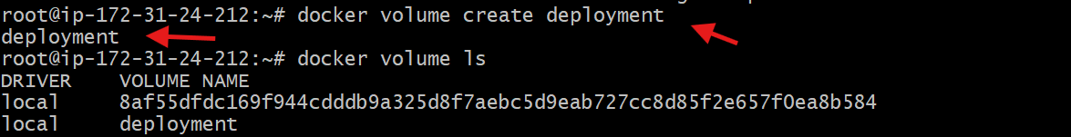
3.Navigated to Docker volumes directory on the host
Command: cd /var/lib/docker/volumes/
4.Entered the deployment volume directory
Command: cd deployment
5.Moved into the _data directory of the volume
Command: cd _data
6.Downloaded the Tomcat sample application WAR file into the volume
Command: wget https://tomcat.apache.org/tomcat-5.5-doc/appdev/sample/sample.war
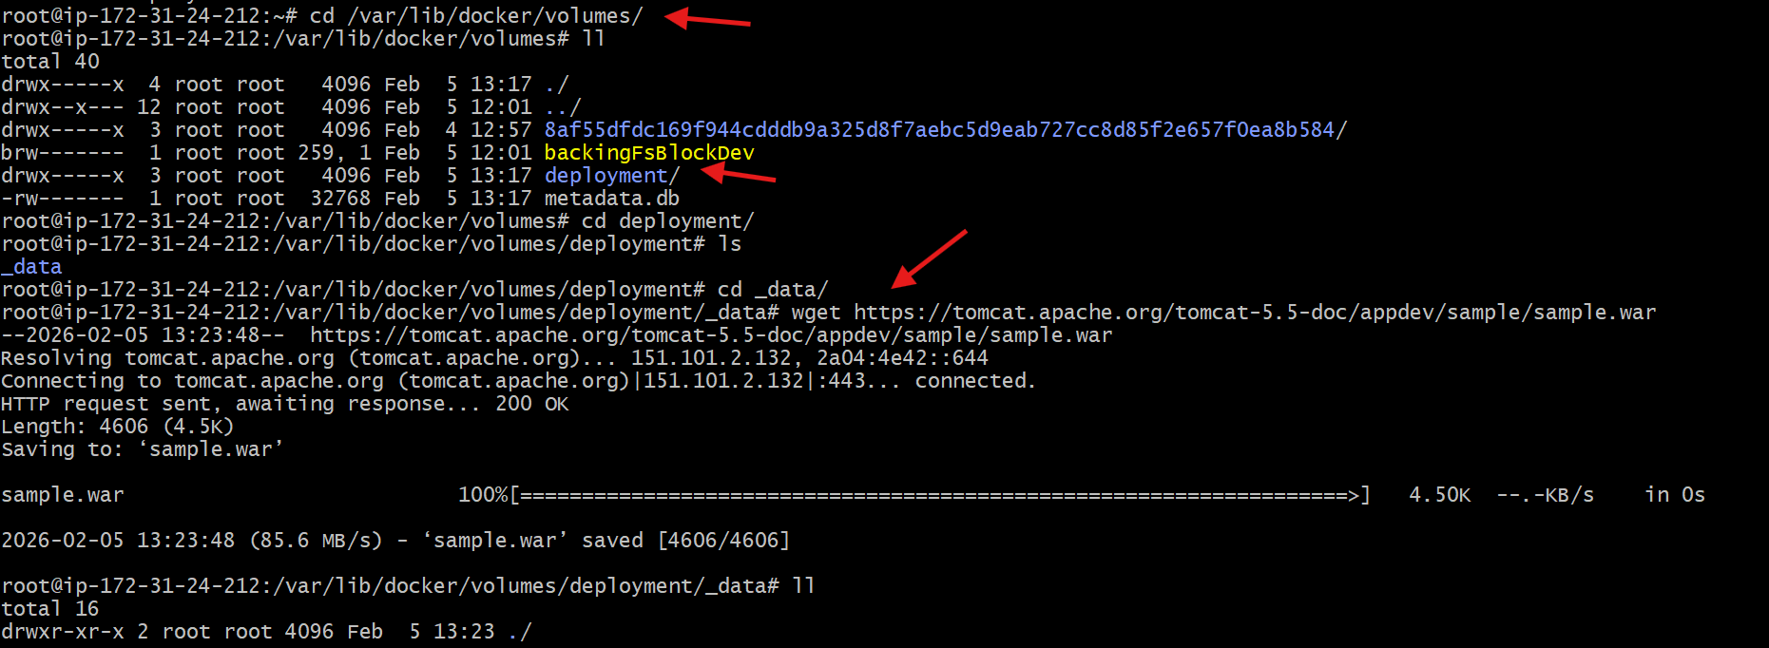
7.Ran a Tomcat container and mounted the volume to Tomcat webapps directory
Command: docker container run -itd -p 8081:8080 \-v /var/lib/docker/volumes/deployment/_data:/usr/local/tomcat/webapps \
tomcat
8.Verified the running containers
Command: docker ps
9.Accessed the deployed sample application in the browser
Browse: http://<server-ip>:8081/sample

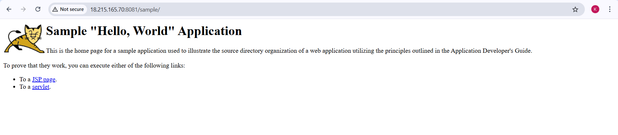

- Limit the nginx container to 500 MB.
Steps performed:
- Ran an Nginx container in detached and interactive mode with a memory limit of 500 MB and mapped host port 82 to container port 80
Command: docker container run -itd -p 82:80 --memory 500m nginx
2.Verified the container was created and running
Command: docker ps
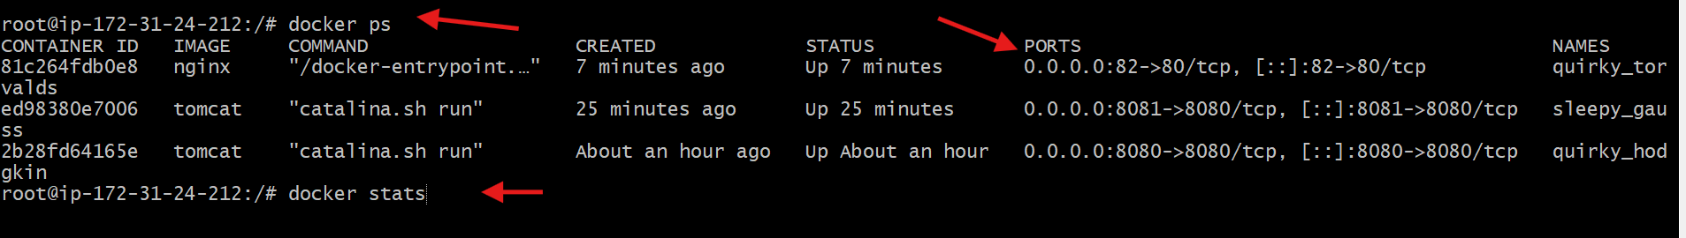
3.Checked real-time resource usage of running containers
Command: docker stats
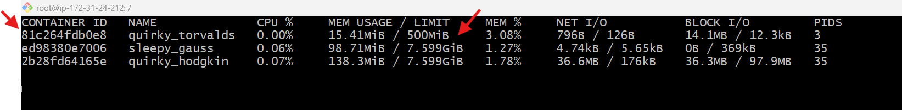
4.Accessed the Nginx default web page from the browser
Browse: http://<server-ip>:82
5.Confirmed port mapping and container status in the Docker process list
- Host port 82 mapped to container port 80
- Container status shown as Up
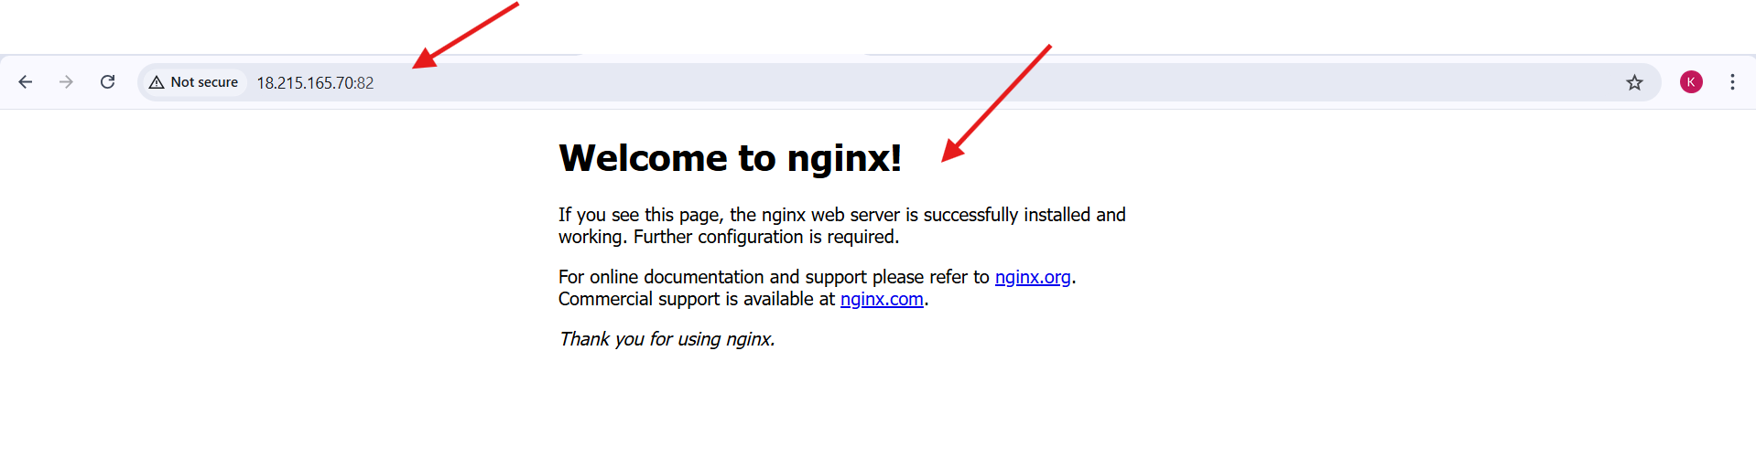

- Create a sample docker file using below instructions.
- Base module as amazonlinux:latest
- Maintainer you name
- Install nginx
- COPY one index.html file to image
- Expose on port 80
- Command to start the nginx container
Steps Performed
- Created a new directory for the Docker project.
Command: mkdir amazon-nginx
- Navigated into the project directory.
Command: cd amazon-nginx
- Created a custom index.html file.
Command: vi index.html
- Added HTML content to index.html and verified the file.
Command: cat index.html
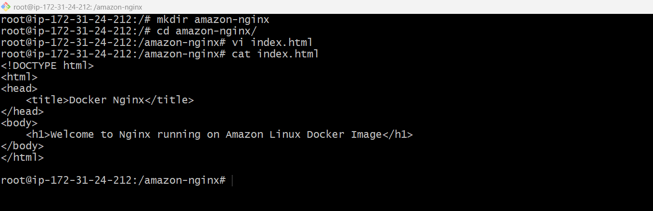
- Created a Dockerfile.
Command: vi Dockerfile
- Added Dockerfile instructions to:
- Use amazonlinux:latest as the base image
- Set maintainer name
- Install nginx
- Copy index.html to nginx document root
- Expose port 80
- Start nginx in foreground
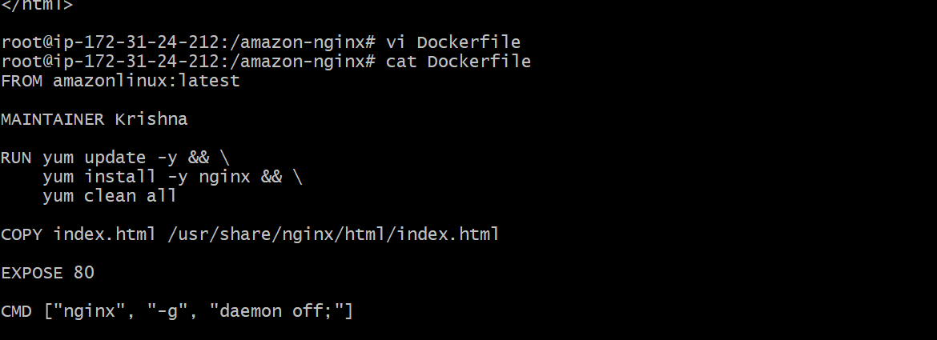
- Built the Docker image using the Dockerfile.
Command: docker build -t amazon-nginx .

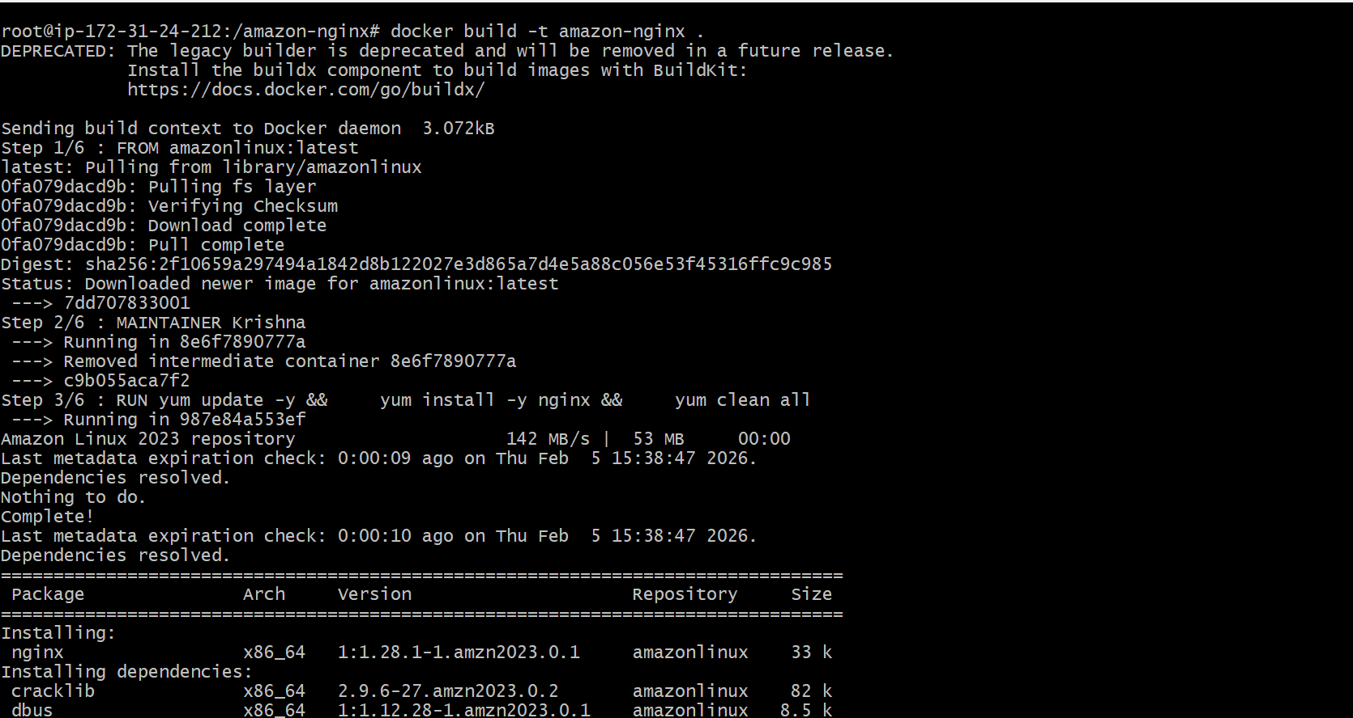
- Verified that the Docker image was created successfully.
Command: docker images
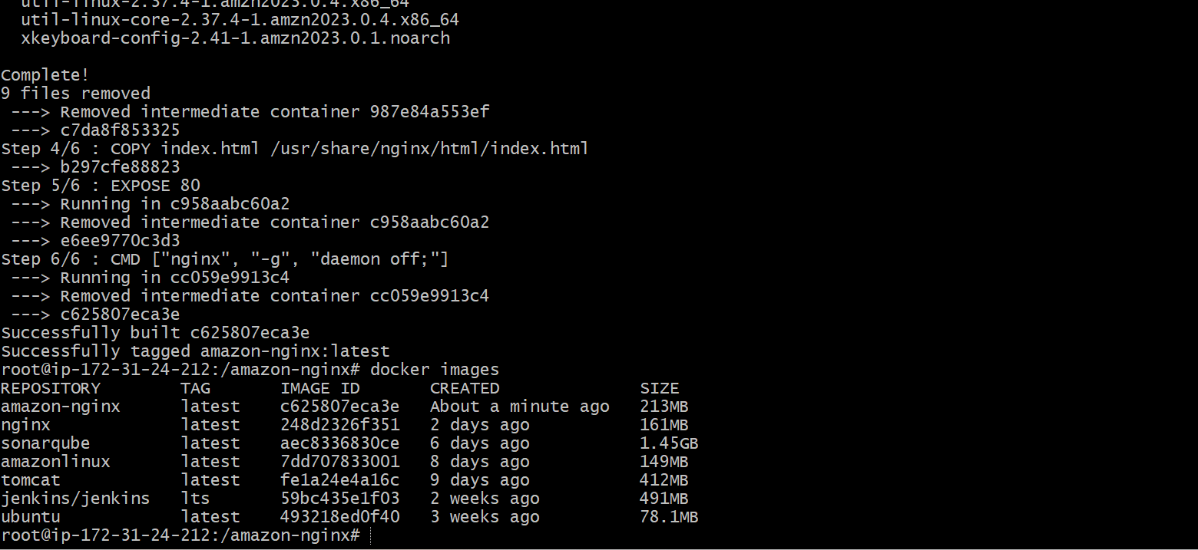
- Ran a container from the custom image and mapped port 80.
Command: docker run -itd -p 80:80 amazon-nginx
- Checked the running containers to confirm the container status.
Command: docker ps
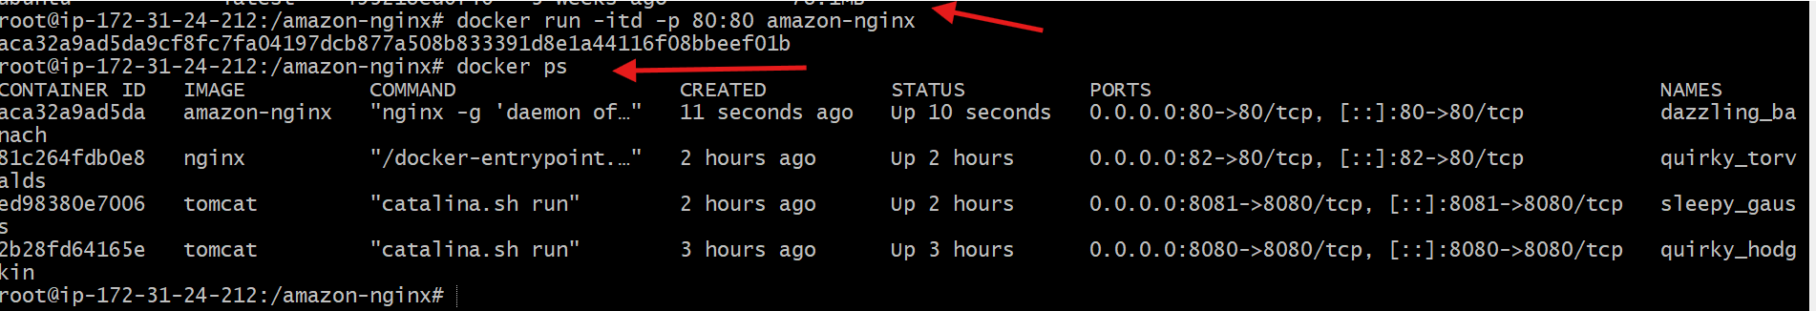
- Accessed the application from the browser using the server IP.
Browse: http://<server-ip>
- Verified that the custom Nginx welcome page was displayed successfully.
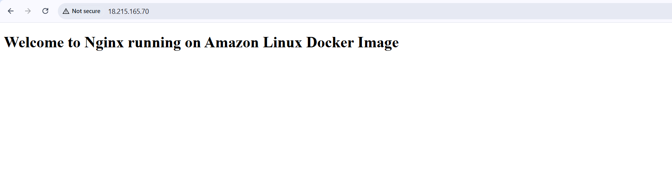

- Push image to Docker hub
Steps Performed:
Step 1: Login to Docker Hub (Web UI)
- Open browser
- Go to https://hub.docker.com
- Login using Docker Hub credentials
Step 2: Create a new repository in Docker Hub
- Click Repositories → Create repository
- Enter repository name: amazon-nginx (or docker_task as shown)
- Select Public visibility
- Click Create
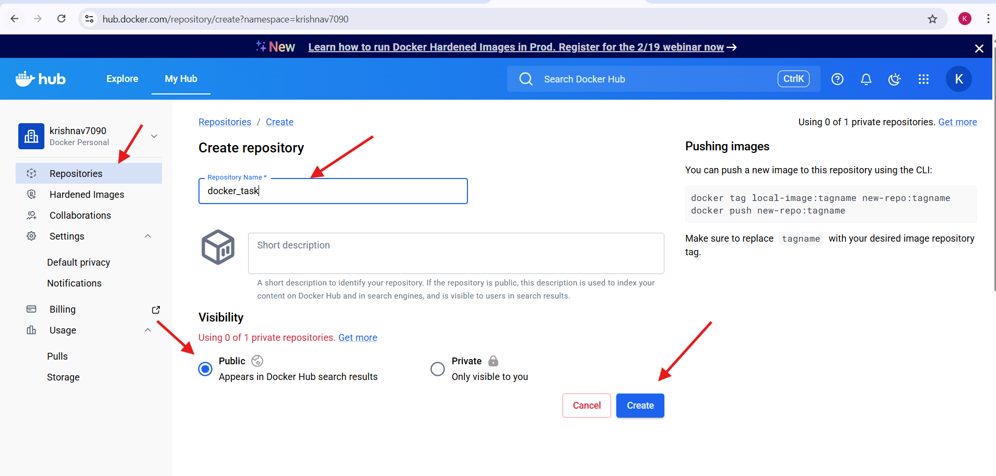
Step 3: Login to Docker Hub from CLI
Command:
docker login
- Complete browser/device verification
- Login successful message displayed
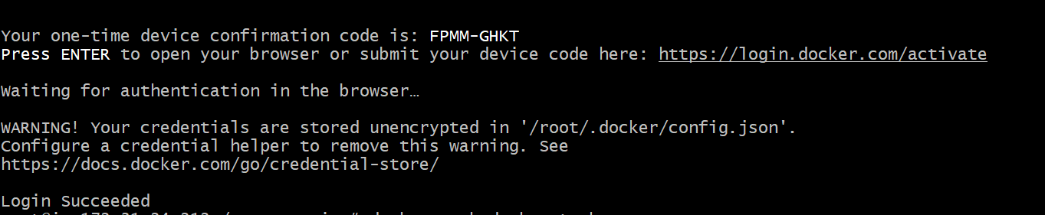
Step 5: Tag the local image with Docker Hub username
Command:
docker tag amazon-nginx krishnav7090/amazon-nginx:latest
Step 6: Verify the tagged image
Command:
docker images
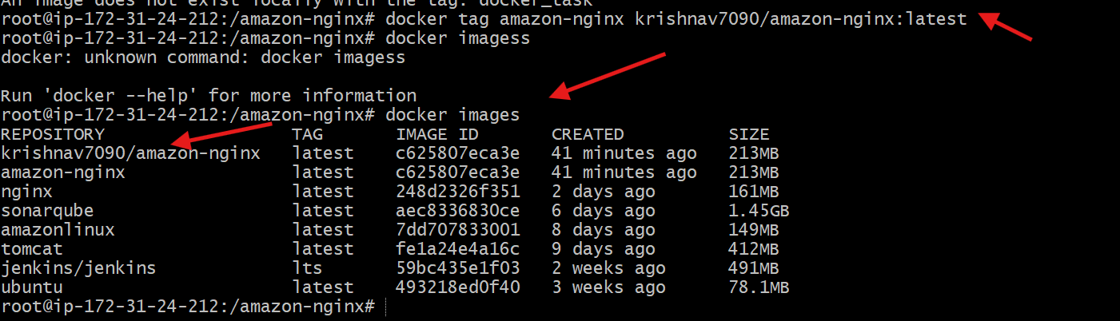
Step 7: Push the image to Docker Hub repository
Command:
docker push krishnav7090/amazon-nginx:latest
Step 8: Confirm image push success
- Push status shows Pushed
- Digest and size displayed
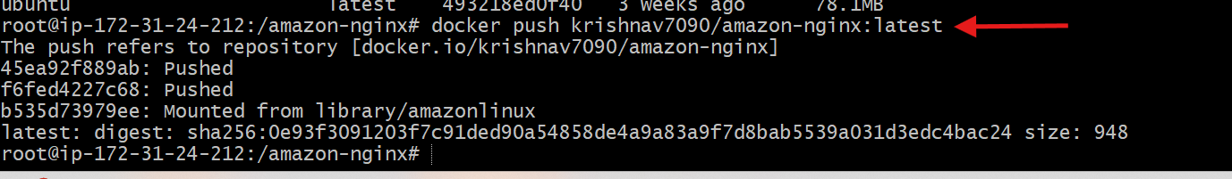
Step 9: Verify image in Docker Hub (Web UI)
- Navigate to Repositories → amazon-nginx
- Confirm:
  - Image name: krishnav7090/amazon-nginx
  - Tag: latest
  - Status: Successfully pushed
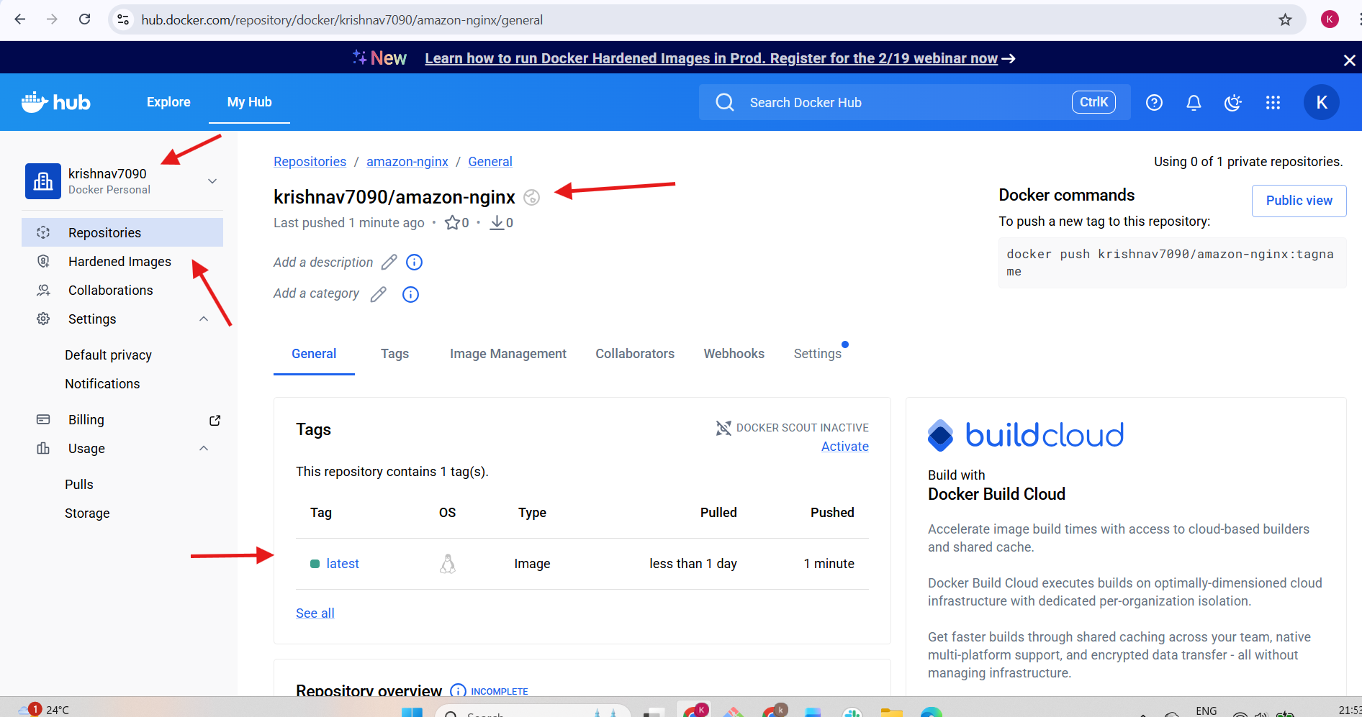

- push image to AWS ECR
Steps Performed:
Step 1: Open Amazon ECR in AWS Console
- Logged in to AWS Management Console
- Navigated to Amazon Elastic Container Registry (ECR)
- Clicked Create repository
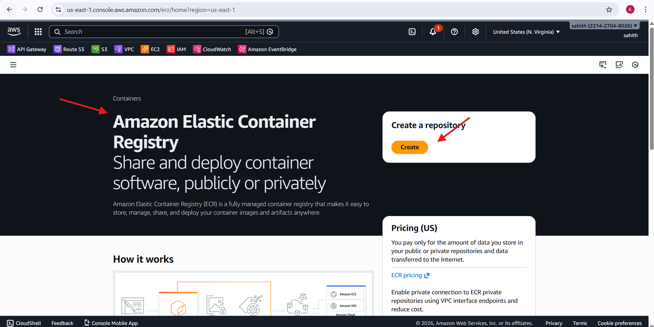
Step 2: Create a Private ECR Repository
- Selected Private repository
- Entered repository name: amazon-nginx
- Kept image tag mutability as Mutable
- Clicked Create repository
Step 3: Verify Repository Creation in ECR
- Navigated to Private registry → Repositories
- Confirmed repository amazon-nginx was created successfully
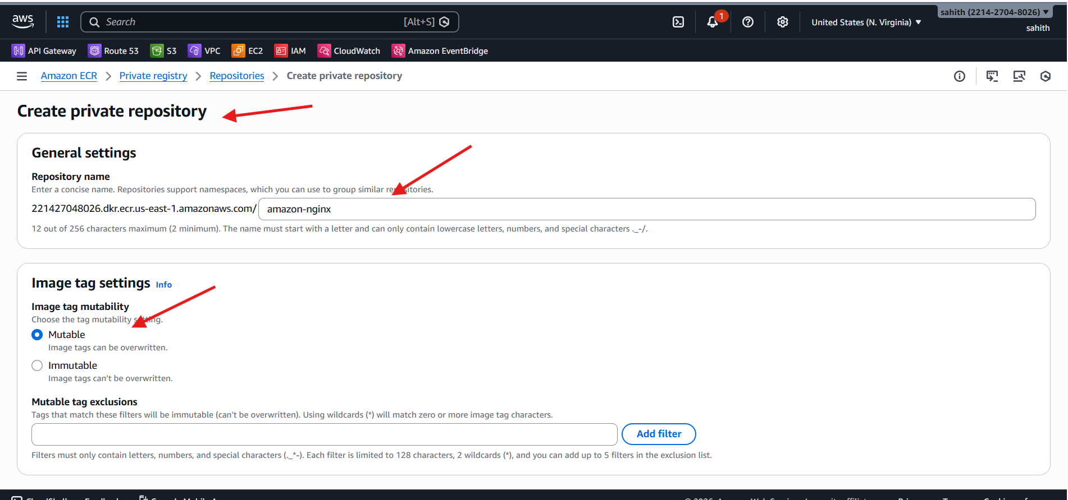
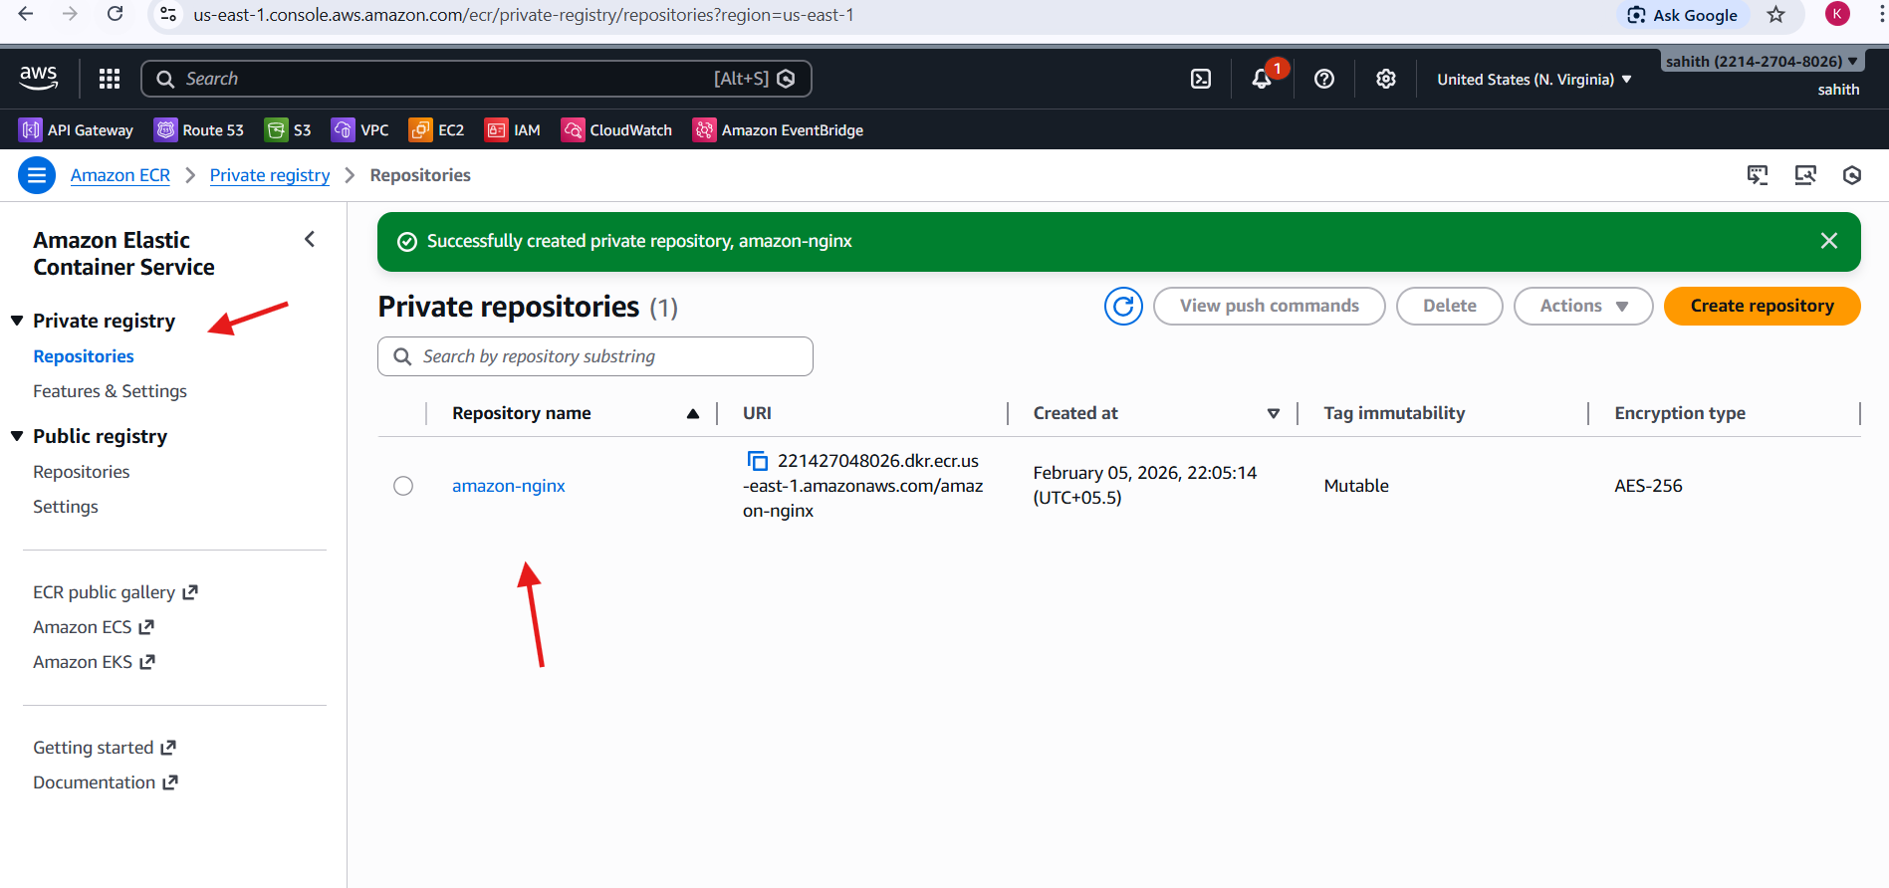
Step 4: Download AWS CLI v2 Installer
Command:
curl "https://awscli.amazonaws.com/awscli-exe-linux-x86_64.zip" -o awscliv2.zip
Step 5: Unzip AWS CLI Installer
Command:
unzip awscliv2.zip
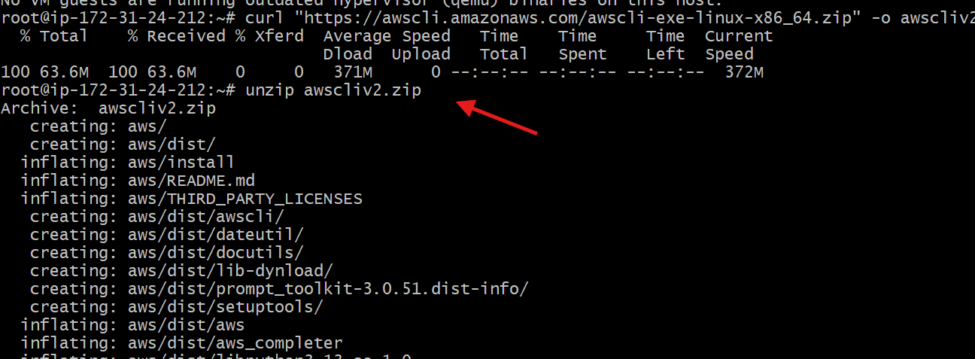
Step 6: Install AWS CLI
Command:
sudo ./aws/install
Step 7: Verify AWS CLI Installation
Command:
aws –version
Step 8: Configure AWS CLI
Command:
aws configure
- Entered AWS Access Key
- Entered AWS Secret Key
- Set default region: us-east-1
- Set output format: json
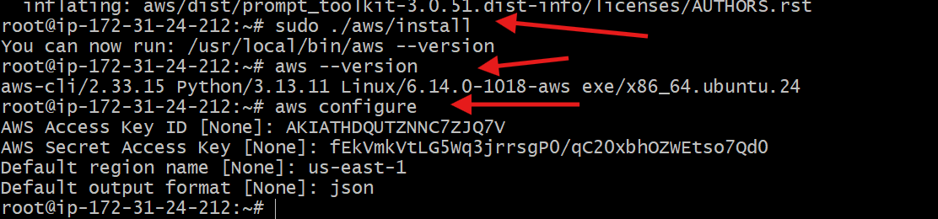
Step 9: Verify AWS Account Identity
Command:
aws sts get-caller-identity
- Confirmed AWS Account ID: 221427048026
Step 10: Authenticate Docker to AWS ECR
Command:
aws ecr get-login-password --region us-east-1 | \
docker login --username AWS --password-stdin 221427048026.dkr.ecr.us-east-1.amazonaws.com
- Login succeeded
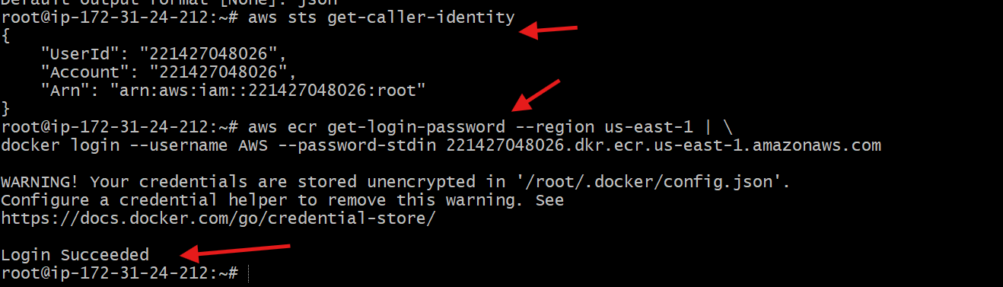
Step 11: Tag Docker Image for AWS ECR
Command:
docker tag amazon-nginx:latest \
221427048026.dkr.ecr.us-east-1.amazonaws.com/amazon-nginx:latest
Step 12: Verify Tagged Docker Image
Command:
docker images
Step 13: Push Docker Image to AWS ECR
Command:
docker push \
221427048026.dkr.ecr.us-east-1.amazonaws.com/amazon-nginx:latest
- Image layers pushed successfully
- Digest generated
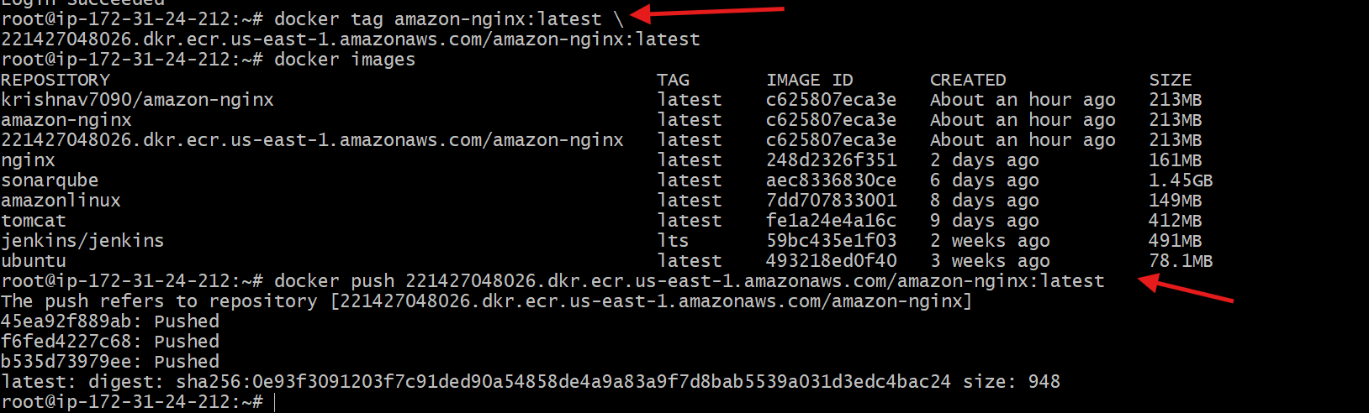
Step 14: Verify Image in AWS ECR Console
- Navigated to ECR → Repositories → amazon-nginx
- Opened Images tab
- Confirmed image tag latest is available
